**Assignment 4**

1 a) Laplacian Transform

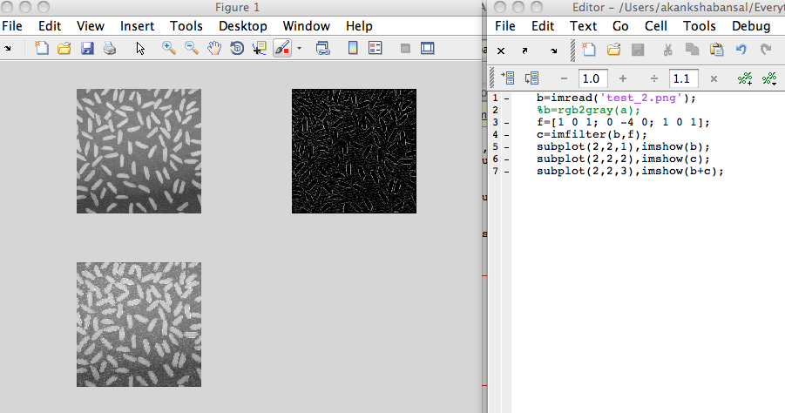

Image 1 is the original image. Image 2 is obtained after applying laplacian transform on the input image. Image 3 is the final sharpened image obtained by adding image 1 and image 2.

b)

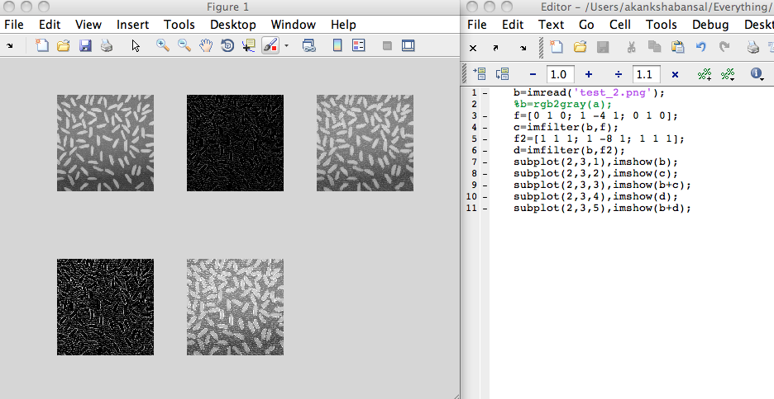

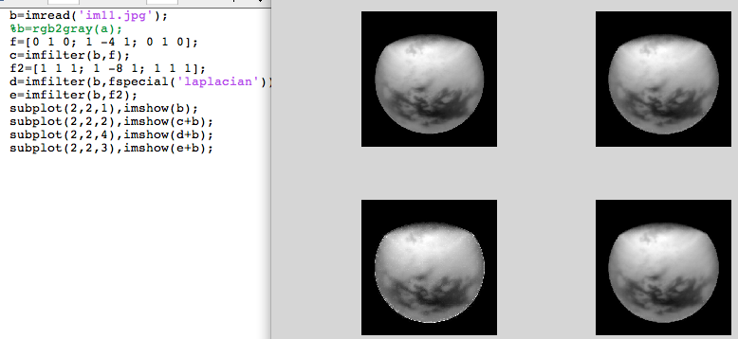

The image 1 is the original image. Image 2 and image 4 are same but as their masks are same but the mask of image 4 has been generated by using fspecial. The image 3 is much more sharper image as it’s mask more effective.

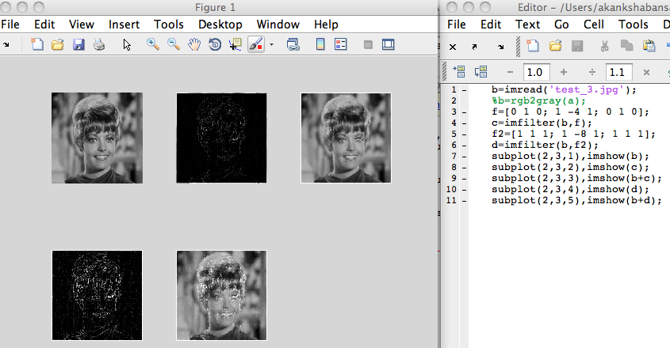

Image 2 and image 4 are the images generated after applying the mask. Image 3 and image 5 are the final sharpened images obtained by adding the initial image to the output after applying the mask.

2 a) Averaging Filter

Image 2 is the blurred image obtained after applying averaging filter [0 1 0; 1 1 1; 0 1 0]*(1/5) and image 3 is the averaging filter. This filter can also be generated using fspecial(‘average’);

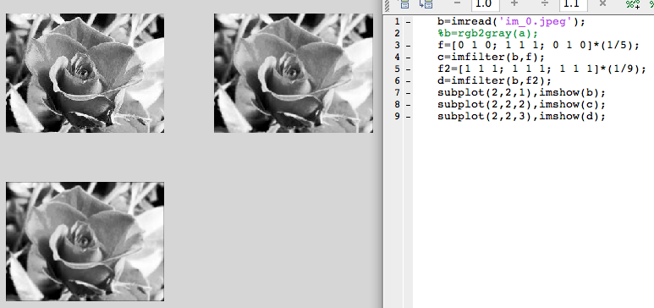

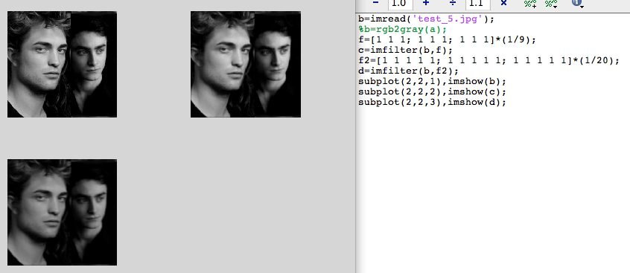

Use of 3x3 averaging filter and 5x5 averaging filter. These filters can be generated by using fspecial(‘average’) and fspecial(‘avrage’, 5).

2 a) Sobel Operator

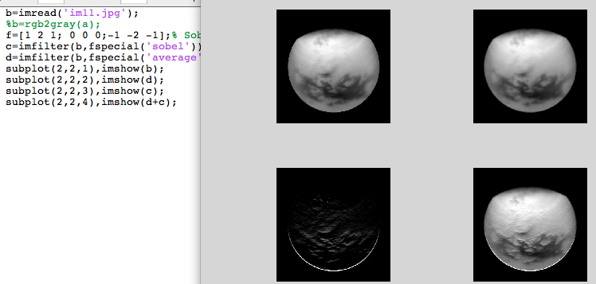

Image 2 is the blurred image obtained after applying averaging filter.

Image 3 is the sharpening mask obtained after applying the Sobel operator. Mask [1 2 1; 0 0 0; -1 -2 -1]. Generated using fspecial(‘sobel’).

Image 4 is the sharped image.

b) Robert’s Filter [1 1; -1 -1 ]

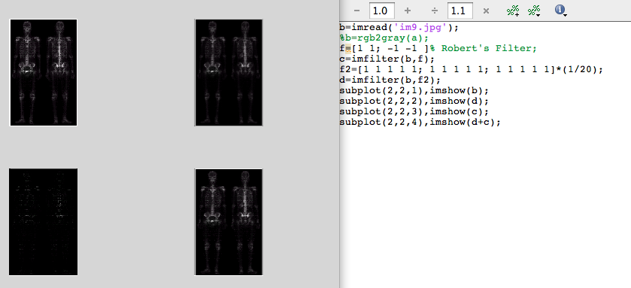

Image 2 is the blurred image obtained after applying averaging filter.

Image 3 is the sharpening mask obtained after applying the Roberts operator. Mask [1 1; -1 -1]. Image 4 is the sharped image.

Non Linear Filter:

1. Median Filter

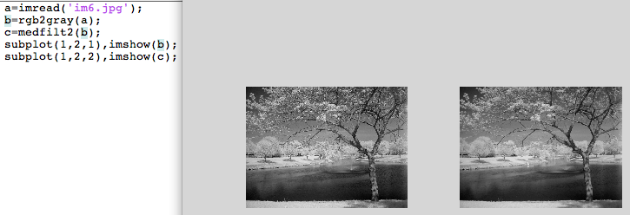

1. Max Filter

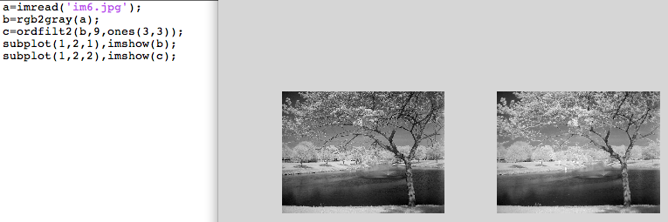

This image is relatively brighter than the original image.

1. Min Filter

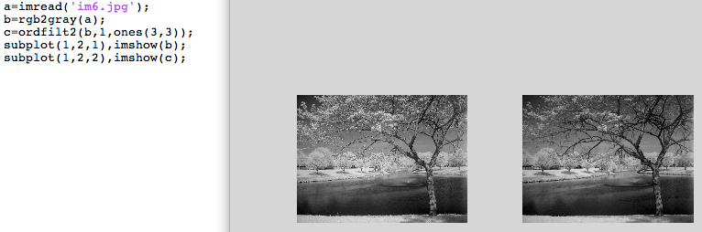

This image is relatively darker than the original image.

Using them to reduce noise.

a. Median Filter:

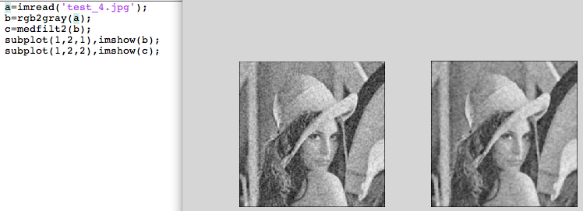

b, Max Filter

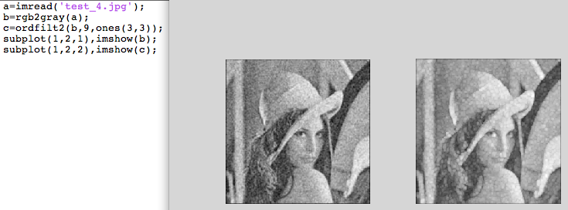

c. Min Filter

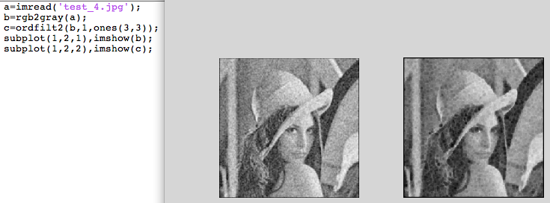

Assignment 3

Histogram Matching

The image 1 is the original image and image2 is the image with whos histogram we will match the original histogram. The third image is the output which has been obtained after histogram matching.

